PreLoad 1.1.2 Download and Installation

1. Copy and paste <https://github.com/teamalpha345/PreLoad-1.1.2> into browser
2. Click the drop down ‘Clone and Download’ button – located top right of the page

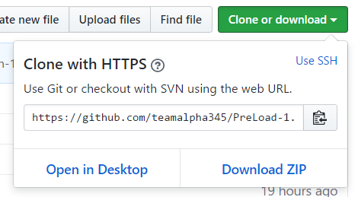

1. Select Download ZIP
2. Extract the downloaded ZIP
3. Open file PreLoad.xcodeproj in Xcode (download Xcode from <https://developer.apple.com/xcode/> if not already installed)
4. Change simulator to iPhone 7 or iPhone 7 plus



6

7

1. Select the play button
2. Wait for simulation to run
3. Use app! (See User Manual for instructions)